Software Development Models

Models
Waterfall
Iterative
Spiral
Big Bang
Agile
Rapid Application Development

One of the first, and considered the most fundamental model, is the Waterfall method.
As one stage is completed, the next starts. Like a series of waterfalls with the water flowing from one waterfall to the next.


Waterfall
Of the stages of the software development cycle, as one stage completes, the next starts. The name calls to mind a series of waterfalls, falling/spilling from the top pool of water (Requirements Gathering) to the next water (Analysis or Design).

Positives:
Simple project structure
Suitable for small to medium projects
Easy to test
Clear deadlines
Better quality of final product

Negatives:
Requirements at each stage must be complete and precise
Does not easily allow for adjustments as the project progresses
Cannot test final product features until the end, hence problems cannot be addressed in mid-development
Mistakes early in the development process has cascading effects down project.
Does not adapt well to unexpected issues.

More applicable to small development groups, projects with long development times (to allow stages to completely finish) and projects with strict requirements that can be fully documented.
Due to testing restrictions and rigid project planning, companies look to more flexible models.

Agile/Scrum

The development team works with the end user stakeholders during the development process. The project is broken up into mini-cycles, that last about a month. At the end of each of these cycles, there is a MVP (Minimum Viable Product) that the stakeholder can test. An MVP would not include all the functionalities, but of the functionalities that it has, they work start to finish. (The Tic-tac-toe example would be an MVP – it lacks the statistics and preventative validation). As each cycle ends, the requirements for the next cycle can be used as originally planned or modified.

Positives:
Very flexible.
High stakeholder involvement so good chance of final product acceptance
Quick testing

Negatives:
Lack of documentation, change process
No clear vision of the end goal
No set deadlines
Difficulty with long term planning for resources

Miscellaneous Project Items

Tracking

Once a project starts, regardless of model, progress is tracked to make sure the project completes reasonably on time, and with the estimated cost.

Example:
Tracking of the Tic-Tac-Toe Development

4:30 5:15 Design Developer 1
5:45 6:00 Design Developer 1
9:00 9:45 Coding Developer 1
9:45 10:15 Design, Coding Developer 1
10:15 11:15 QA, Fixing Developer 1

An astute observer would notice that the code has some differences to the Design Specifications. This is not a result of feature creep, but of a natural occurrence. Often, a problem arises and a change must be made to the specifications. But there is usually a formal process to make changes to a project’s specifications – a change control process that weighs the pros and the cons to the project.

For example, while coding, it was determined that the Planning had not explicitly stated what to do if a Draw occurred. That situation was decided to be crucial to the project, and time will be spent adding it to the specifications and design.

Status Report

Current time spent to this point of the project : 2.25 hrs
Projects usually have regular status reports made to senior team members, to make sure development is proceeding according to the schedule.

Example:
Identified necessary changes to Design
Added ability to Draw Change Management

Identified further possible requirements
Should prevent user from selecting invalid position Deferred

Outstanding : Statistics functionality
Regression testing

Risk Assessment
Original requirements do-able
Possible to address new requirement

Project Software

Gantt Chart

A Gantt chart is a visual technical project management tool which shows activities or tasks against a time line. They immediately show the scheduled duration of tasks, and start and finish times, but also can show or manage dependencies and critical paths.

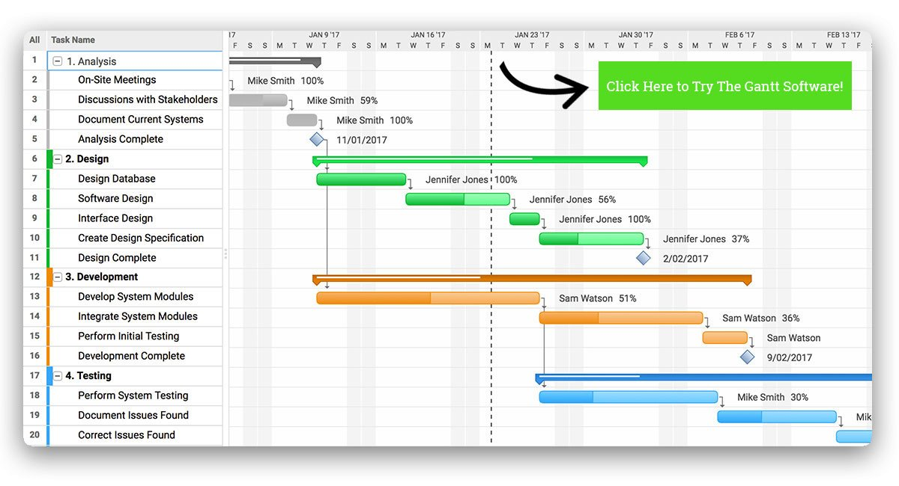
Dependencies refer to the relation s between tasks that must be completed before another can start. Critical paths are the set of tasks that must be completed for the project to be completed on time.

No exercises for this lesson.

